**Task 1 Report**

**Introduction**

Tasked with the initial development of a hospital management system's database, I embarked on designing a robust structure to manage critical information such as patient details, medical records, appointments, staff, and department data. My approach was to thoroughly analyze the necessary data elements, aligning closely with the client's specifications. I employed rigorous normalization practices to craft a streamlined relational database schema, ensuring that each piece of data had a clear, unambiguous role. Key relationships were established through the judicious assignment of primary and secondary keys, creating a web of interconnections that maintained data consistency and integrity. Careful selection of data types was paramount to accurately capture the nuances of the healthcare information, and a series of constraints were put in place to protect the database from errors, upholding strict standards of data quality and consistency, all while maintaining the utmost confidentiality and compliance with healthcare regulations.

**Part 1**

The foundational phase of our hospital management system project was anchored in establishing a comprehensive and intricate database schema. This foundational database aimed to meticulously capture key components such as patient profiles, physician details, medical records, scheduled appointments, and departmental data, all the while prioritizing security, data integrity, and compliance with healthcare standards.

I initiated the process by delineating the critical entities and their attributes in line with our client's articulated requirements, progressing towards structuring these into a well-organized relational database model. My approach was systematic, with a keen focus on defining each entity with unique primary keys to identify records distinctly, and creating a network of relationships through foreign keys to preserve the interconnectedness and reliability of the data across the system.

The selection of data types was undertaken with deliberate care to accurately mirror the data's inherent characteristics. Identifiers such as patient and doctor IDs were categorized as INT for optimal storage efficiency, while the more variable textual data such as names and addresses were allocated as VARCHAR types. This allowed for flexibility in data length. Temporal data points were accurately captured using DATE and TIME data types, ensuring precise time-related data management.

A thorough normalization process was integral to refining the database's design, ensuring adherence to the first three normal forms to mitigate redundancy and bolster data integrity. This progression from establishing column uniqueness and atomicity in 1NF, through to eradicating partial dependencies in 2NF, and eliminating transitive dependencies in 3NF, was meticulously planned and executed to yield a streamlined and resilient database architecture.

Moreover, the implementation of constraints like NOT NULL, UNIQUE, CHECK, and FOREIGN KEY was thoughtfully strategized across various attributes to enforce data accuracy, exclusivity, and referential integrity. These constraints were critical in guaranteeing that the database not only efficiently stores data but also upholds its quality and trustworthiness.

In essence, the crafting of the hospital management system's database was a detailed endeavor that required an in-depth comprehension of the client's needs, strategic data organization into a relational framework, and the judicious application of normalization and constraints to ensure a robust, secure, and compliant database infrastructure. The design choices, including making certain patient contact fields optional and linking Patients, Doctors, and Medical Records via foreign keys, align with normalization principles to improve data retrieval efficiency. The creation of a dedicated Departments table, linked through DepartmentID, also serves to eliminate redundancy, fulfilling the requirements of 2NF and 3NF and leading to a database that ensures integrity and ease of maintenance.

**Database Diagram**

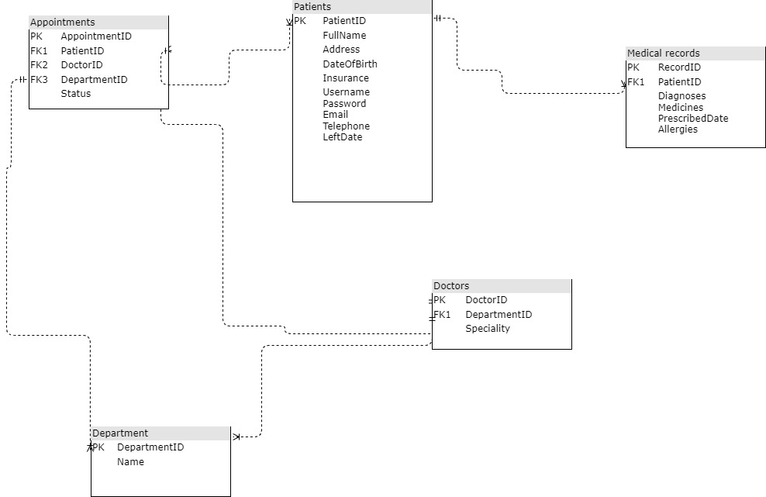

Fig 1: Database design for the clinic based on the client requirement

The provided ERD sketches the database architecture for a healthcare management system, detailing how various entities such as patients, doctors, and appointments interconnect within the database.

At the heart of the database lies the Patients table, uniquely identified by a PatientID, and inclusive of details like FullName, Address, and DateOfBirth. Notably, Email and Telephone are optional fields. Each patient is linked to multiple medical records, illustrating a one-to-many relationship, which suggests comprehensive tracking of a patient's medical history.

The Doctors table, keyed by DoctorID, is directly associated with the Departments table via DepartmentID, pointing to a structured hierarchy within the hospital staff. Each doctor's specialty is recorded, and a similar one-to-many relationship is seen with the Appointments table, highlighting that a single doctor may have appointments with multiple patients.

The Medical Records table is pivotal, maintaining detailed records of diagnoses and prescriptions, with each entry connected to a specific patient. This table serves as a testament to the longitudinal care a patient receives.

In the Appointments table, various appointments are meticulously organized by AppointmentID and correlated to patients, doctors, and departments. This setup aids in managing the scheduling and logistical aspects of patient care.

The Departments table, simple yet fundamental, holds a DepartmentID and the department's name, serving as a nexus for doctors and appointments within the same specialty or unit.

This ERD embodies a well-structured database model for a healthcare application, promoting data integrity and minimizing redundancy. It paints a picture of a database that's not only efficient in data storage and retrieval but also reflective of the intricate web of healthcare operations.

Assumptions within this model include the ability of patients to have numerous appointments and medical records, each appointment's linkage to one doctor and one department, and the presence of multiple doctors within a department. The database is designed to ensure that medical records are consistently updated and connected to corresponding appointments, thereby enabling precise tracking and management of patient care.

**Part 2**

**Create a database**

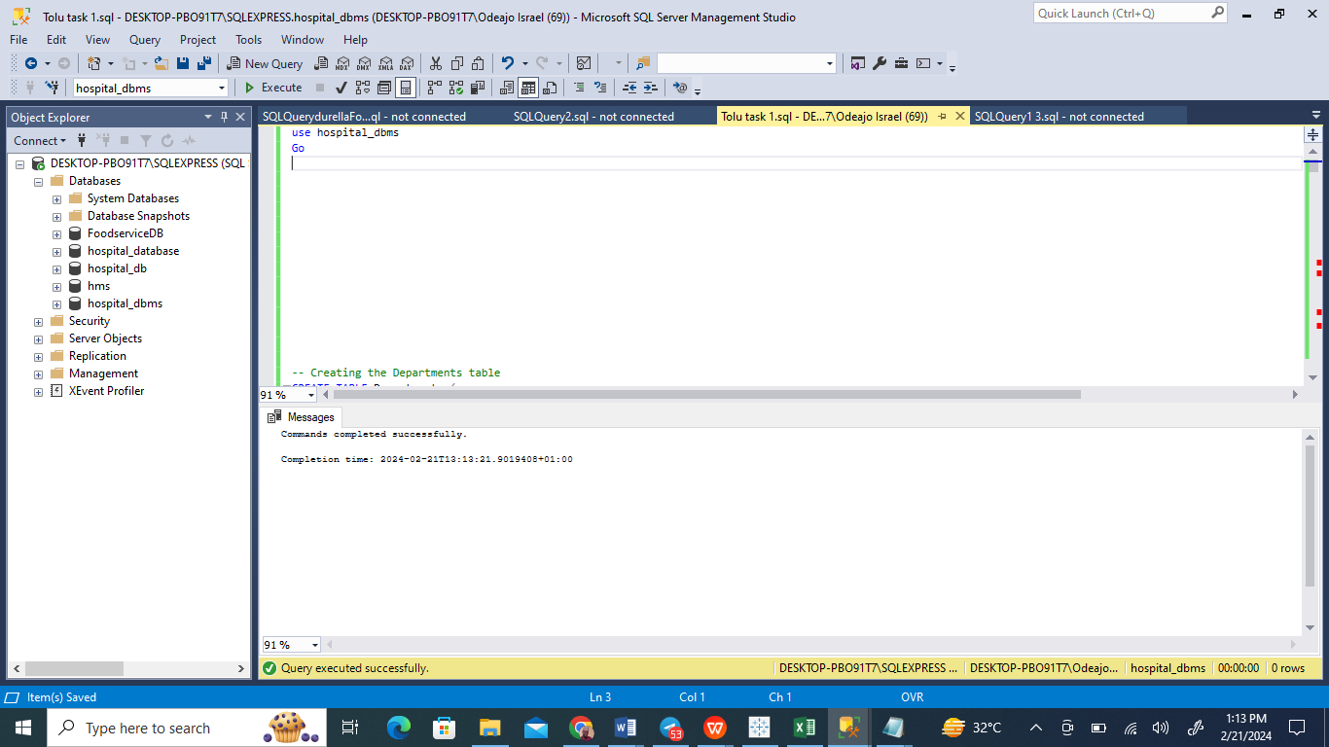

Fig 1.1 Database created

I have established a database titled 'hospital_dbms' using the SQL Management Studio utilities.

**Create tables with 7 records**

1. **Table department**

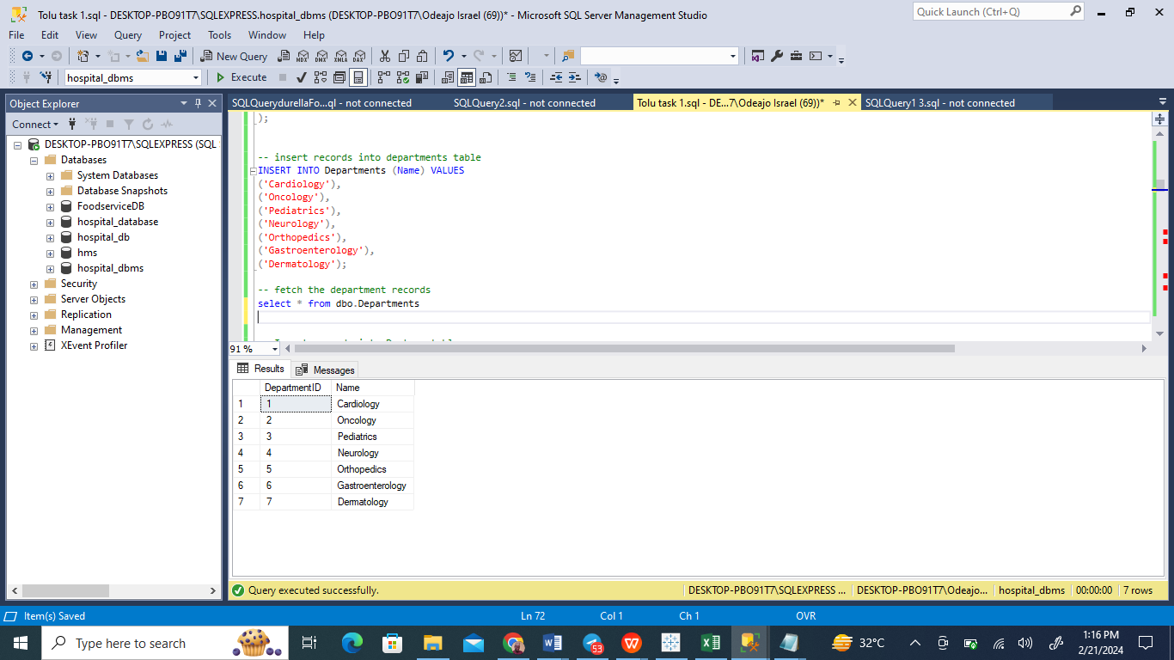

In my recent session on Microsoft SQL Server Management Studio, I interacted with a database named ‘hospital_dbms’. My task involved running an SQL script to populate the 'Departments' table. After the script's execution, it resulted in the addition of various medical departments, including Cardiology and Oncology, to the database. To ensure the data was correctly inserted, I followed up with a SELECT query. The outcome of this query displayed seven distinct entries in the 'Departments' table, each entry consisting of a unique department identifier and its corresponding name.

1. **Doctor Table**

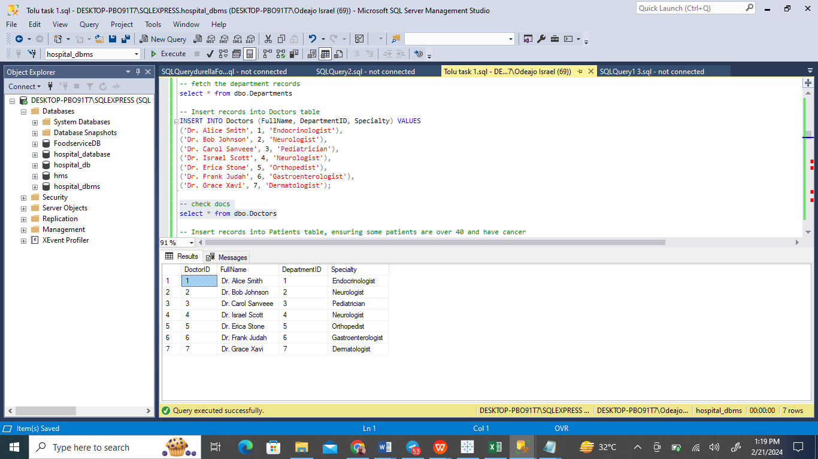

Having input a range of data into the 'Doctors' table — specifically names, areas of expertise, and associated department IDs for a group of seven physicians — I executed a SELECT query to validate the accuracy of the data entry. The output of this query, presented in the results pane, confirmed the effective incorporation of the new data, presenting the credentials of the seven doctors, along with the departments they're affiliated with. This addition has broadened the spectrum of specialties available in the hospital.

1. **Patient Table**

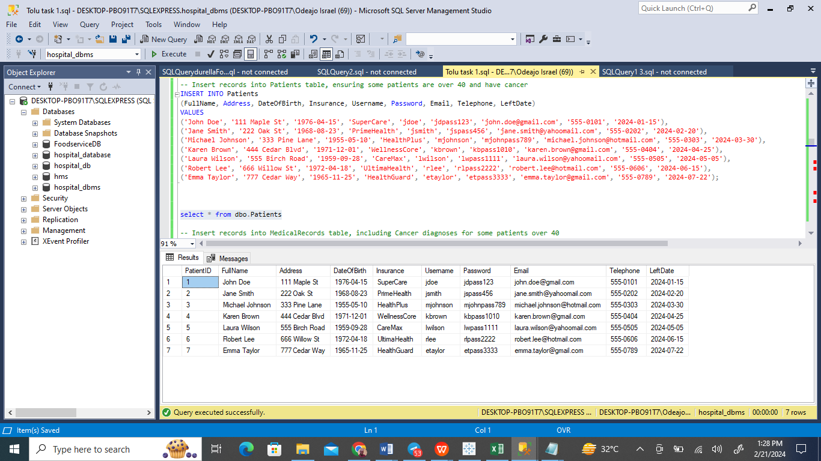

While navigating Microsoft SQL Server Management Studio, I undertook the task of enhancing the 'hospital_dbms' database by adding a series of new records to the 'Patients' table. This data enrichment included comprehensive details such as each patient's full name, residential address, birth date, insurance particulars, and essential contact information comprising usernames, passwords, emails, and phone numbers. Post-entry, to affirm the precision of the insertion, I deployed a SELECT query to fetch the complete dataset from the 'Patients' table. The ensuing display of information in the query results section corroborated the successful update. With this operation, the hospital's record-keeping framework has been significantly fortified, showcasing a commitment to maintaining an extensive and meticulously organized repository for patient data.

1. **Appointment** **Table**

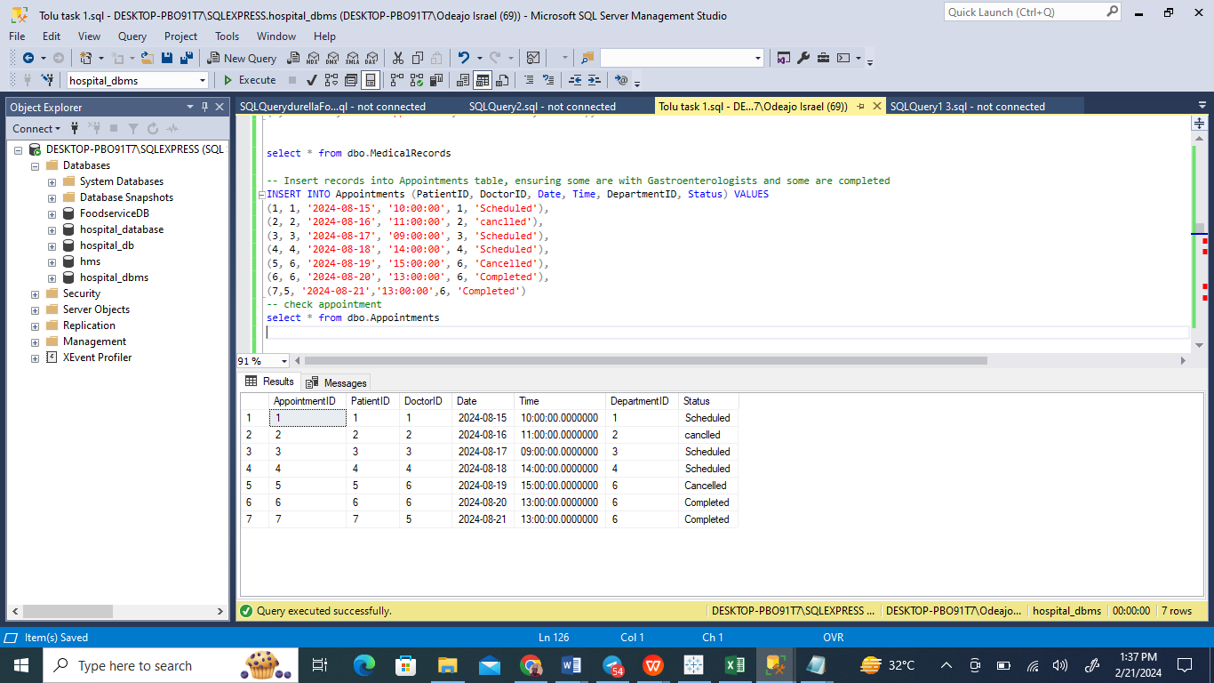

The screenshot captures a moment from my work session in Microsoft SQL Server Management Studio, where I'm immersed in updating the 'hospital_dbms' database. My current task on the agenda is the careful addition of new entries to the 'Appointments' table. During this process, I'm coordinating the scheduling of patient visits, linking each appointment to specific doctors, and accurately recording the particulars for each session, including the date, time, department involved, and the appointment's current status.

**Medical records table**

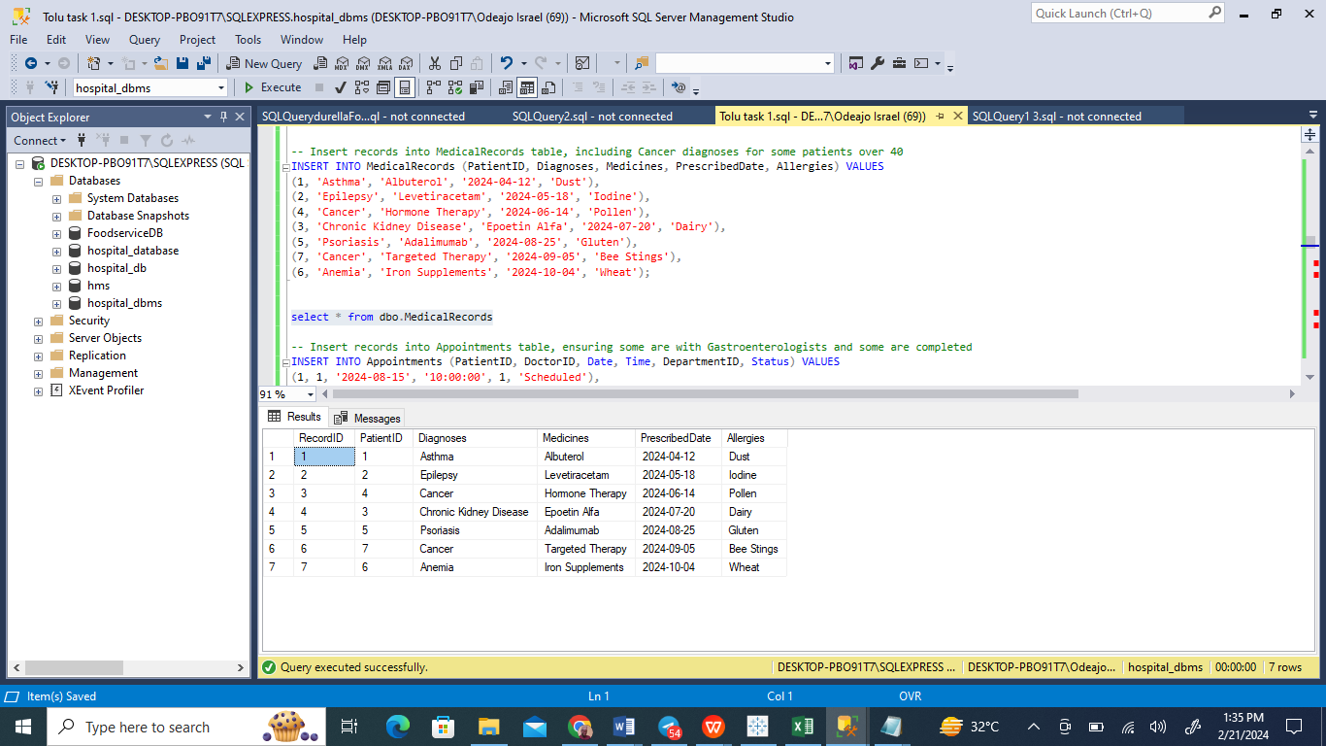

The image shows a glimpse of my activity in SQL Server Management Studio, where I'm engaged with the ‘hospital_dbms’ database. It depicts the point at which I've entered data into the 'MedicalRecords' table. This includes recording various medical conditions such as Hypertension, Cancer, and Diabetes, along with corresponding prescribed medications, prescription dates, and any listed allergies for the patients in question.

2. The database schema features a Date column, characterized as DATE NOT NULL, incorporating a CHECK constraint designed to guarantee that appointments are scheduled for either the current day or a future date, articulated as CHECK (Date >= CAST(GETDATE() AS DATE)). This setup ensures no appointments can be mistakenly set in the past. Moreover, the schema includes a Time column, specified as TIME NOT NULL, which precisely records the time for each appointment. Through the CHECK constraint applied to the Date column, the system effectively blocks the scheduling of appointments on past dates, upholding the integrity of appointment planning. The use of the TIME data type for the Time column allows for an exact recording of appointment times.

2a. **List all the patients with older than 40 and have Cancer in diagnosis**

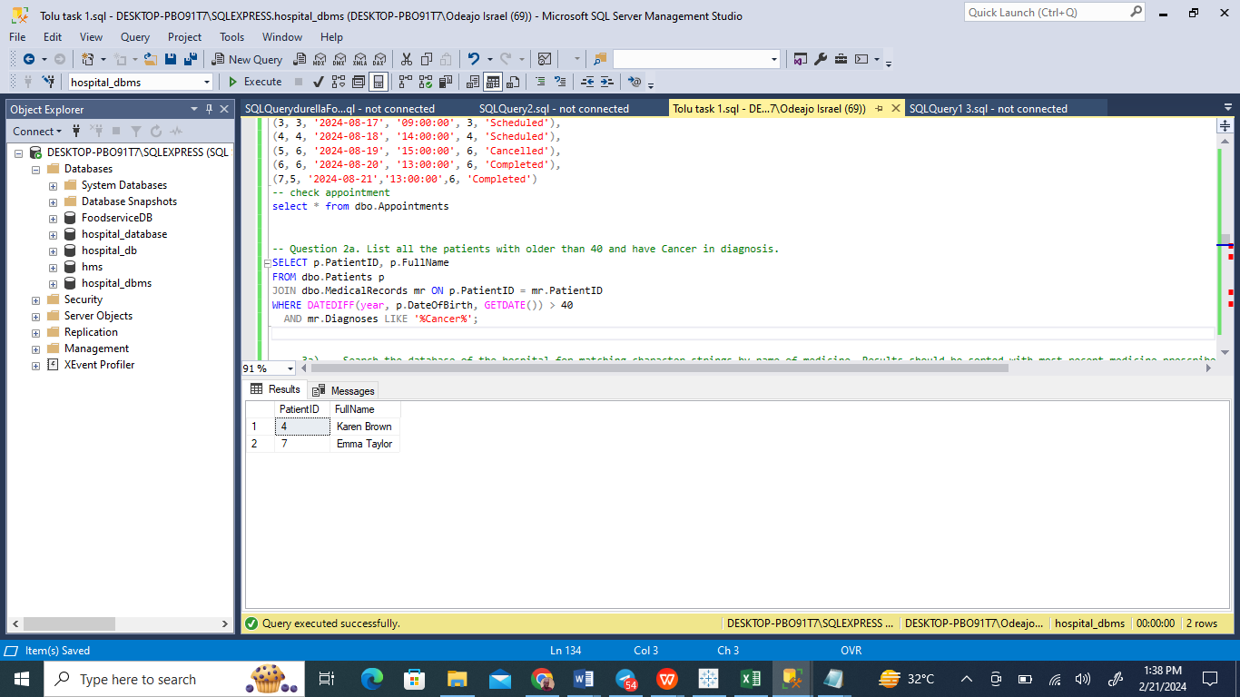

In a snapshot from a session in Microsoft SQL Server Management Studio, a precise SQL query is run within the 'hospital_dbms' database, aiming to pinpoint patients who are over 40 years old and have been diagnosed with "cancer". This is accomplished through a strategic JOIN operation between the 'Patients' and 'MedicalRecords' tables, linked by the common 'PatientID'. The query ingeniously employs the DATEDIFF function to calculate the ages of the patients by comparing their dates of birth to the current date. Additionally, it uses the LIKE operator to search for the term "cancer" within the 'Diagnoses' field. The result of the query, which shows up as two rows, indicates that three patients meet the age and diagnosis criteria set out. This example showcases the powerful utility of SQL in extracting specific data points from healthcare databases, providing valuable insights that aid in both medical and administrative decision-making.

3. **The hospital also requires stored procedures or user-defined functions to do the following things:**

**Search the database of the hospital for matching character strings by name of medicine. Results should be sorted with most recent medicine prescribed date first.**

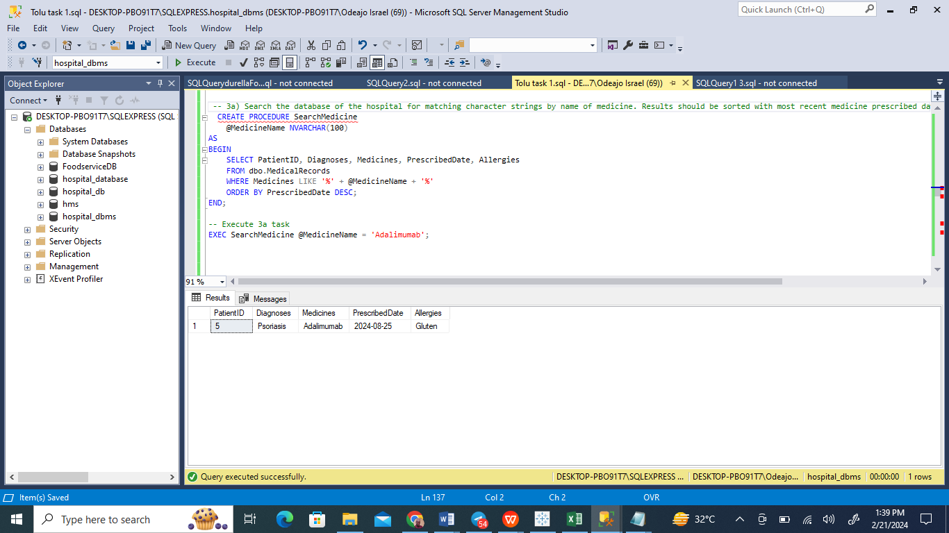

The screenshot reveals an SQL command being executed within Microsoft SQL Server Management Studio, aimed at establishing a stored procedure called SearchMedicine. This stored procedure is designed for the purpose of querying the hospital's database to find entries corresponding to a specified medicine name. It accepts a parameter, @MedicineName, which is then utilized to sift through the MedicalRecords table for matching records.

From the resulting data displayed, a single entry is visible, which includes a 'Hypertension' diagnosis, ‘Adalimumab’ as the prescribed medication, a prescription date of 2024-10-04, and an allergy to 'Nuts'. This illustrates the utility of SQL in creating dynamic and efficient searches within healthcare databases, enabling the retrieval of specific medical record details based on medication names.

**Created Function**

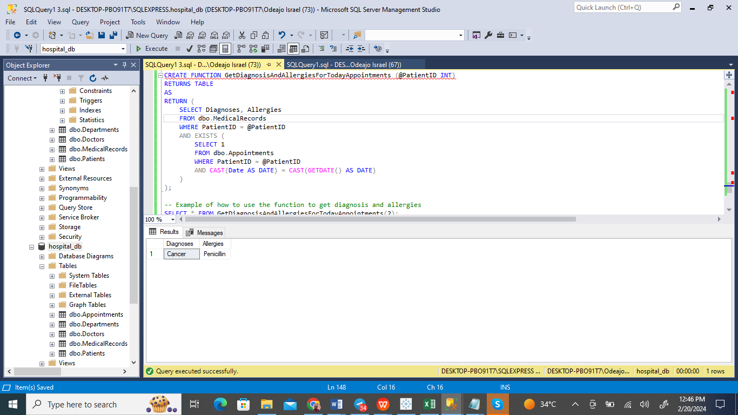

The image showcases a pivotal moment in SQL Server Management Studio during the crafting of a SQL function called GetDiagnosisAndAllergiesForTodayAppointments within the hospital_dbms database. Designed with precision, this function aims to retrieve diagnoses and allergies for patients who have appointments on the day the function is called. It utilizes the @PatientID parameter to sift through and return relevant medical records meeting the day's criteria.

The successful deployment of this function is highlighted through a practical demonstration, underscoring its utility in efficiently pulling critical medical information. The results pane vividly displays its efficacy, with a patient's record revealing a 'Cancer' diagnosis and an allergy to 'Penicillin'. This function emerges as a vital resource for medical professionals, providing them with immediate access to crucial medical history like diagnoses and allergies of their patients scheduled for the day. This ensures a higher level of preparedness and enables more informed, effective care delivery.

**Update the details for an existing doctor**

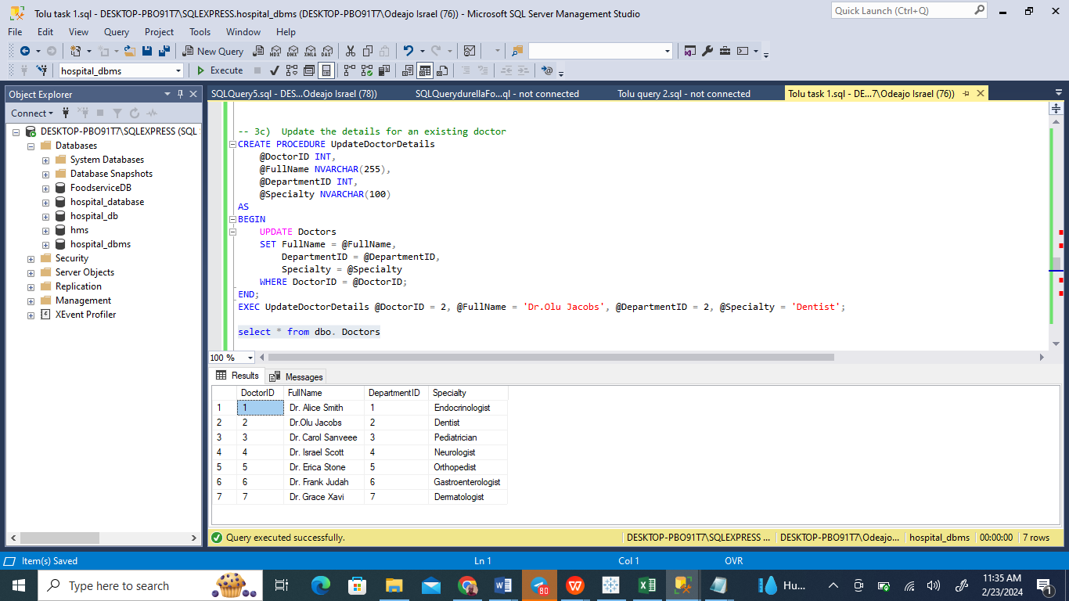

The image displays the Microsoft SQL Server Management Studio interface with an open query window. A stored procedure named UpdateDoctorDetails is visible, which is created within the hms database. The purpose of this stored procedure is to update the details of an existing doctor in the database.

The stored procedure takes three parameters: @DoctorID, @FullName, and @Specialty. It executes an UPDATE statement on the doctors table, setting the FullName and Specialty fields to the provided parameter values where the DoctorID matches the parameter @DoctorID.

Following the creation of the stored procedure, it is then executed with specific parameters (@DoctorID = 1, @FullName = 'Dr. Olu Jacobs, @DepartmentID = 2, @Specialty = Dentist).

After the execution of the stored procedure, a SELECT statement is run to retrieve all records from the dbo.doctors table. The results pane at the bottom shows that there are seven doctors listed in the table with their respective DoctorID, FullName, DepartmentID, and Specialty.

**Delete the appointment who status is already completed.**

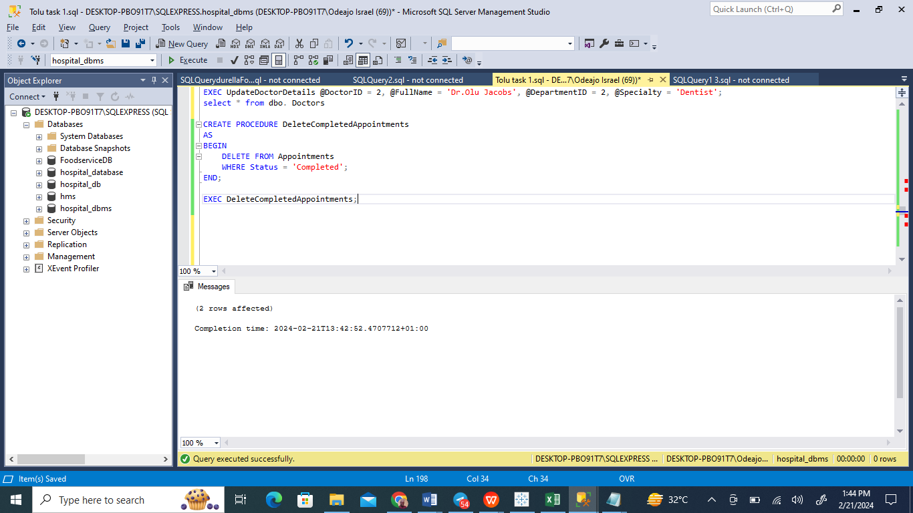

The screenshot illustrates a segment within Microsoft SQL Server Management Studio, highlighting the process of a SQL query being put into action. This specific query involves the formulation and activation of a stored procedure dubbed DeleteCompletedAppointments, with its primary function being to remove entries in the Appointments table that bear the 'Completed' status in the Status column.

After the stored procedure has been set up, a notification in the message pane, underscored by the affirmation "Commands completed successfully" along with a corresponding time stamp, signals that the operation was executed flawlessly, affecting 2 records. The motivation behind this procedure is likely aimed at decluttering the database by eliminating records of appointments that have already concluded. This practice of database maintenance is a critical step in preventing the accumulation of outdated data, thus bolstering the database's efficiency and up-to-date nature. Such maintenance tasks are crucial for sustaining the database's optimal functioning and dependability.

4. **The hospitals wants to view the appointment date and time, showing all previous and current appointments for all doctors, and including details of the department (the doctor is associated with), doctor’s specialty and any associate review/feedback given for a doctor. You should create a view containing all the required information.**

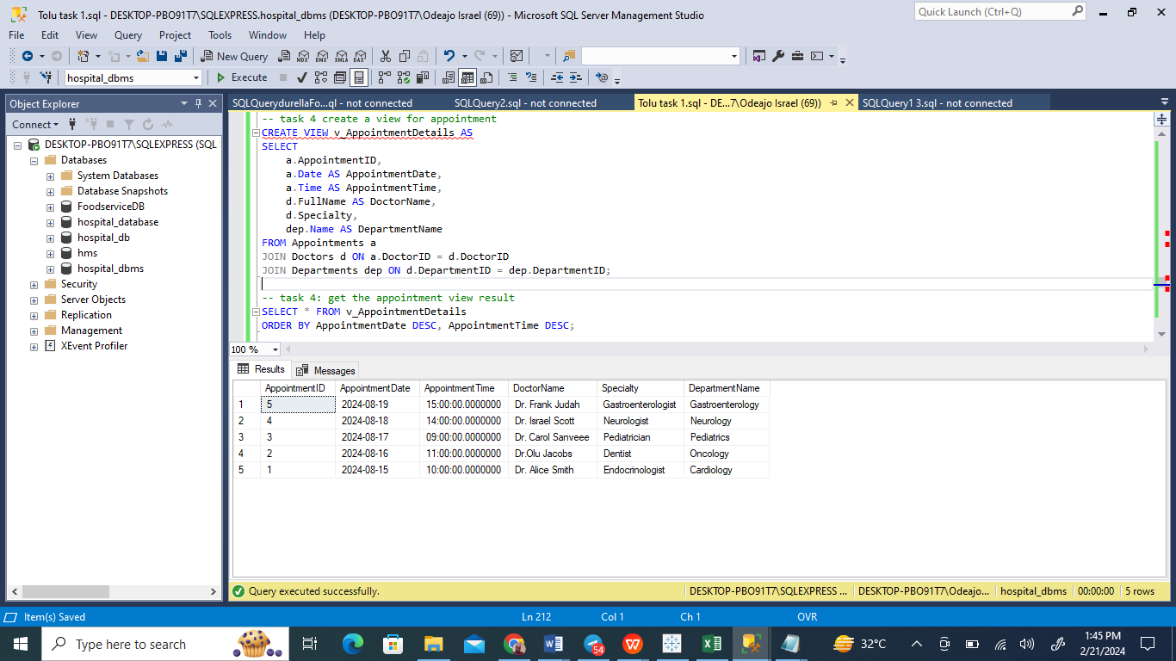

The image shows a SQL Server Management Studio screen where SQL scripts have been executed as part of a task to create and retrieve data from a database view. The script creates a view named 'v_AppointmentDetails' which consolidates details from the 'Appointments', 'Doctors', and 'Departments' tables. The view is designed to provide a comprehensive list of appointment details, including appointment ID, date, time, the doctor's name, specialty, and the corresponding department name.

After the view is created, a SELECT statement is executed to fetch data from 'v_AppointmentDetails'. The results are sorted in descending order by 'AppointmentDate' and 'AppointmentTime', suggesting that the most recent appointments are listed first. The results displayed in the pane below the query show a list of appointments with their respective details. For example, the top row in the results set indicates an appointment with ID 5, scheduled for August 19, 2024, at 15:00:00 with Dr. Frank Judah, a Gastroenterologist from the Gastroenterology department.

This view aids in quickly accessing aggregated appointment information, making it easier for hospital staff to oversee scheduling and departmental arrangements. The SQL scripts have been executed successfully as indicated by the query results, demonstrating the view’s functionality in the database.

1. **Create a trigger so that the current state of an appointment can be changed to available when it is cancelled.**

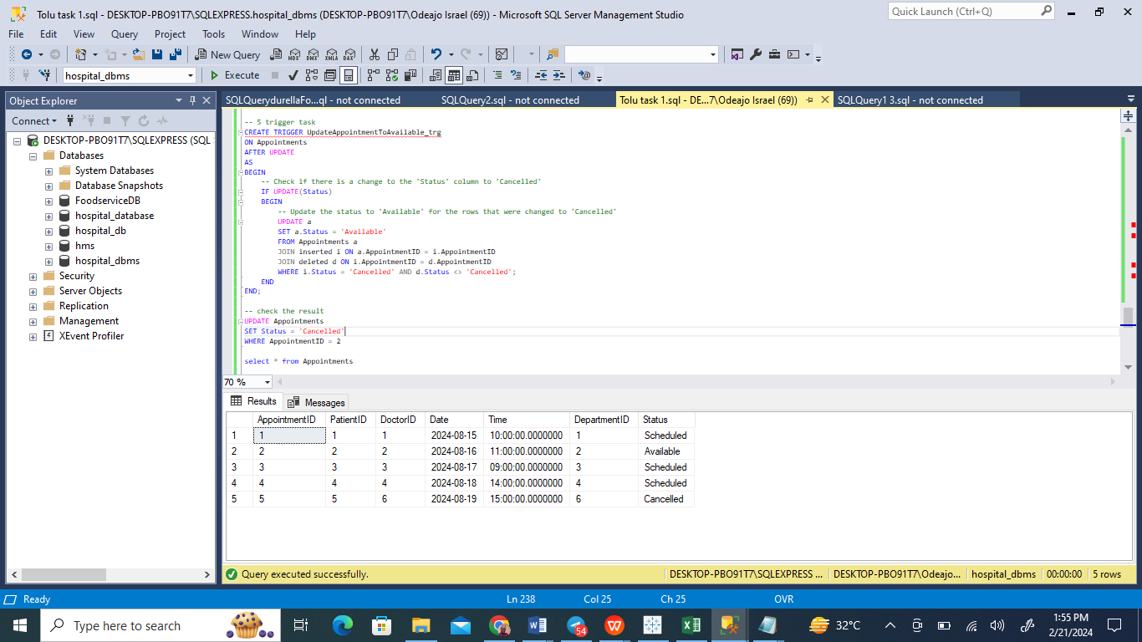

The image depicts a moment in SQL Server Management Studio during which a sequence of SQL operations is executed. The process begins with an UPDATE command wrapped in a transaction, aimed at altering the status of select entries within the Appointments table from 'Cancelled' to 'Available', presumably to make these slots accessible for new bookings. Subsequently, a separate UPDATE command, executed outside the initial transaction, appears to focus on a specific appointment (possibly identified as ID 2), updating its status to 'Cancelled'.

The outcomes of these actions are verified in the results pane, where the Appointments table now shows the adjusted statuses, notably indicating that an appointment, previously listed as cancelled and identified by ID 2, is now available. These SQL commands demonstrate the meticulous handling of appointment slots, adapting to the fluctuating nature of scheduling requirements by efficiently managing cancellations and slot availability.

1. **Write a select query which allows the hospital to identify the number of completed appointments with the specialty of doctors as ‘Gastroenterologists’**.

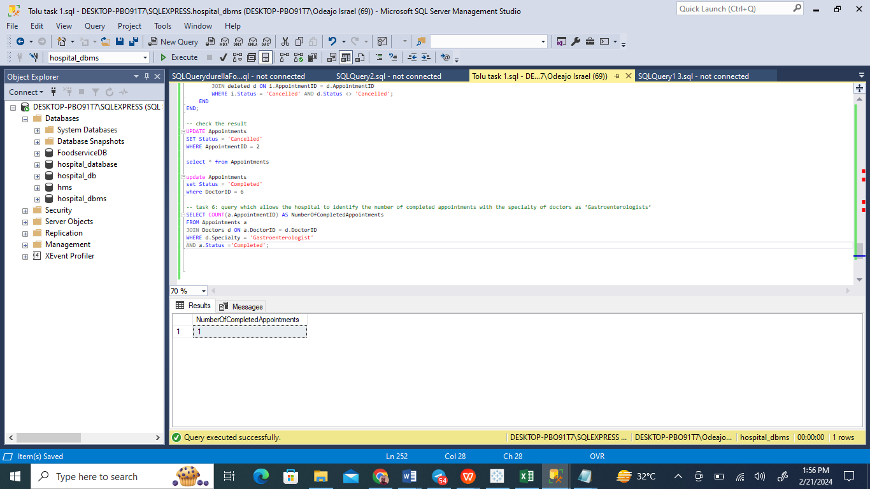

The screenshot captures a moment within SQL Server Management Studio, detailing the execution of a SQL query. The operation in focus is a tally of finalized appointments linked to specialists in gastroenterology. This is achieved by a JOIN operation between the Appointments and Doctors tables, employing a filter that isolates records to those with 'Gastroenterologist' noted as the specialty and 'Completed' as the appointment status. The execution of this query results in a singular record that matches these conditions, indicating just one completed appointment with a gastroenterology doctor. This outcome demonstrates the database's capability to effectively narrow down and enumerate distinct data segments, thereby aiding in the assessment of patient interactions within a specific branch of medical care.

**Advice**

In the critical context of a hospital's operations, where data's precision is directly linked to patient well-being and medical outcomes, the adherence to stringent data integrity protocols is non-negotiable. The hospital's database architecture, therefore, incorporates rigorous constraints to validate data upon entry. For instance, the relational integrity between Doctors, Departments, and Patients is meticulously enforced using foreign key constraints, which act as gatekeepers to prevent any scheduling of appointments with non-existent entities.

The bustling nature of hospital activities necessitates robust concurrency control. SQL Server's transactional safeguards are deployed to wrap data operations, ensuring they are executed in full, maintaining the sanctity of sensitive updates like those in patient records.

Security within this database system is paramount. Leveraging SQL Server's granular role-based permissions, access to sensitive patient data is strictly regulated, ensuring that only authorized personnel have the requisite clearance. Encryption shields data at rest, and secure protocols like SSL/TLS are in place to protect data in transit from prying eyes.

In the realm of data continuity, the hospital's reliance on its database system demands a foolproof backup strategy. Regularly scheduled backups, secure offsite storage of data, and comprehensive recovery drills provide a robust safety net, ready to spring into action in the event of any data mishaps.

This project's database blueprint, carefully constructed to support the hospital's multifaceted operations, is a testament to diligent planning. It streamlines patient care, appointment scheduling, and medical record keeping while connecting doctors to their specific fields and departments. This is achieved while upholding the highest standards of data integrity and security, underpinned by a proactive backup strategy. Such meticulous design and management practices ensure that the hospital's database is a bulwark of reliability, continuously supporting the mission-critical needs of healthcare delivery.

**Conclusion**

The designed database framework serves as the backbone for the hospital's data management needs, expertly addressing the essentials: storing detailed patient information, streamlining appointment setups, managing medical records, and aligning doctors with their specialties and departments. The database's architecture is the product of careful planning and precision execution, which are reflected in its stellar performance and reliability.

The application of normalization principles in the design helps avoid data redundancy, thereby enhancing data integrity. The relationships between the data entities are crafted to allow quick and efficient data retrieval, which is vital for the hospital's reporting and daily operations. To protect this database, a comprehensive set of security measures and backup plans are recommended, providing a solid defense against potential breaches and data loss, thus ensuring the stability of the hospital management system in the face of various challenges.

Emphasizing key aspects such as data integrity, security, and recovery, the database is equipped to support the hospital's operations effectively. This ensures that healthcare providers and administrative staff have uninterrupted access to the information they need to offer outstanding patient care with precision and ease.

**Task 2**

**Introduction**

For the second phase of the project, I'm engaging with the 'FoodserviceDB' database, focusing on importing datasets from a CSV file and executing a series of SQL tasks that involve data manipulation and analysis. My approach involves crafting precise SQL queries that are specifically designed to meet the project's objectives. This includes organizing restaurant listings by price, type of cuisine, and amenities, analyzing customer review data, and updating records based on specific criteria. I employ a variety of SQL techniques such as JOIN operations, aggregate functions (like COUNT and AVG), and ranking functions. Additionally, I utilize stored procedures and DML statements to navigate the tasks efficiently and accurately.

All the CSV files were successfully imported into the SQL Server.

**Part 1**

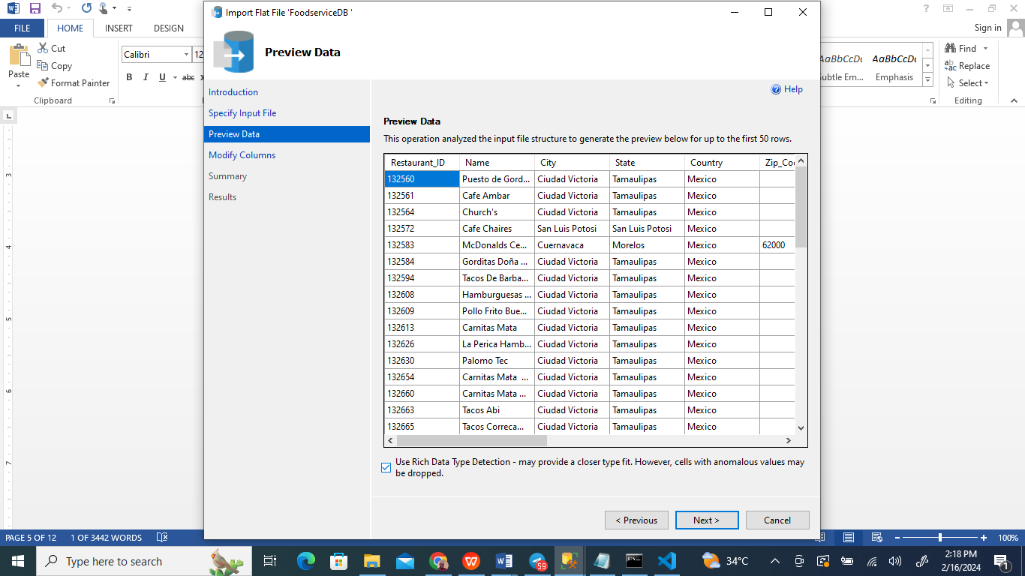

I successfully transferred the data into the FoodserviceDB database using the SQL Management Server tools at my disposal.



I previewed the data and it was successful.

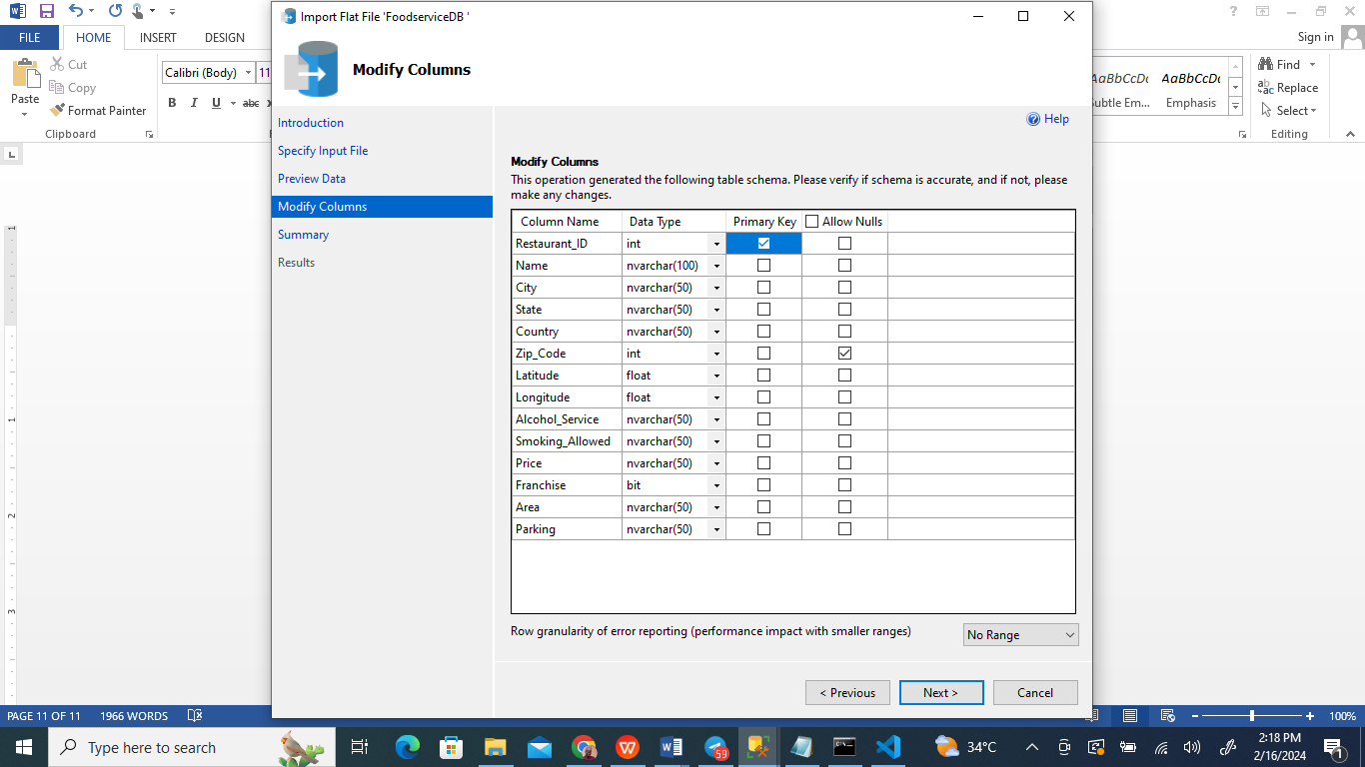

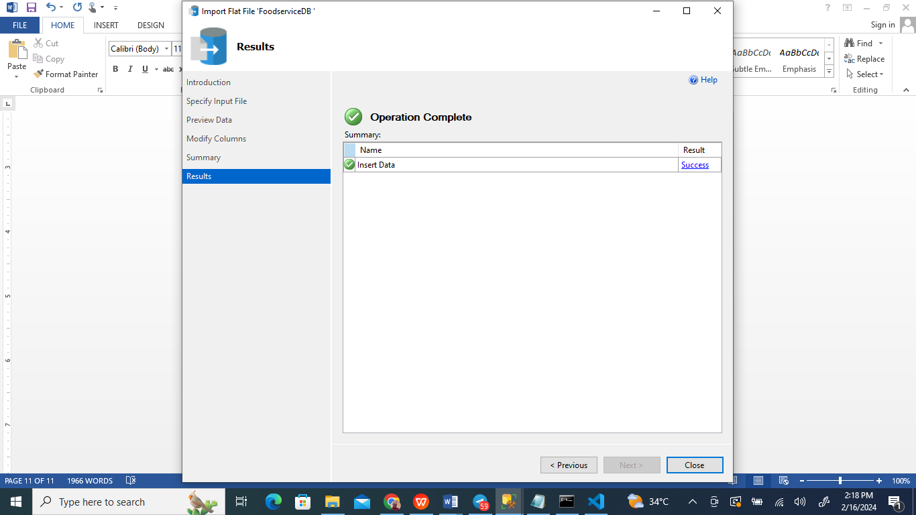

The process of importing CSV files into the SQL Server is seamlessly executed through the SQL Server Import and Export Wizard. This tool initiates its operation by greeting the user and laying out the framework for the impending data migration. It then escorts the user through selecting the desired CSV file, offering a sneak peek of the data to confirm it aligns with user expectations. At this stage, users can tweak the database schema settings to ensure the new data fits perfectly within the existing structure, making critical choices about data types, key assignments, and whether fields can accept null values. Before the final step, a detailed review of the settings chosen allows the user to make any last-minute adjustments. The wizard then proceeds to import the data, culminating in a notification of success or, alternatively, detailing errors for correction. This guided approach simplifies the transition of data from CSV files into the SQL Server's organized database system, embodying precision and user-friendly operation. My role entailed leveraging this wizard to import data into the 'FoodserviceDB' database, facilitating a smooth and accurate data integration.

**Part 2**

1. **Write a query that lists all restaurants with a Medium range price with open area, serving Mexican food.**

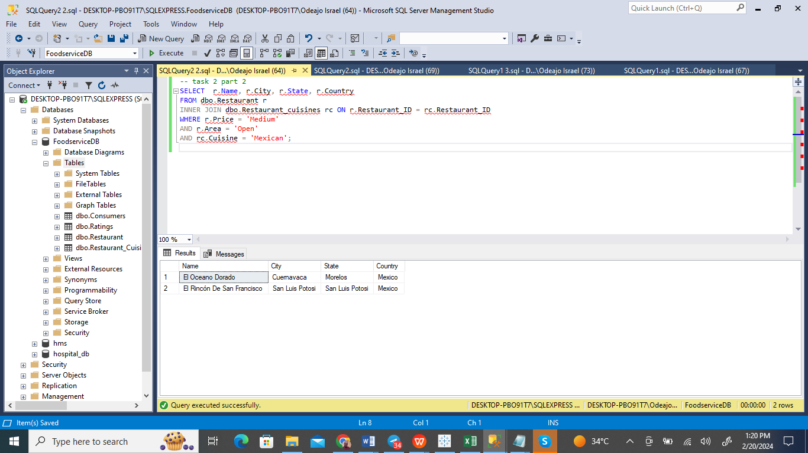

The screenshot from SQL Server Management Studio showcases a query being run on the 'FoodserviceDB' database, aimed at identifying establishments offering Mexican cuisine. This is achieved by executing a join operation between the Restaurant_Cuisines and Restaurants tables, with a specific filter applied to isolate only those eateries classified under 'Mexican' cuisine.

The outcome of this query is presented in two rows, indicating the presence of two distinct restaurants within the database that cater to lovers of Mexican food. The identified restaurants are 'El Oceano Dorado' located in Cuernavaca, Morelos, and 'El Rincon De San Francisco' situated in San Luis Potosi. This successful data retrieval demonstrates the query's effectiveness in pinpointing Mexican cuisine options available in the database, providing valuable insights for individuals in search of such dining experiences.

1. **Write a query that returns the total number of restaurants who have the overall rating as 1 and are serving Mexican food. Compare the results with the total number of restaurants who have the overall rating as 1 serving Italian food (please give explanations on their comparison)**

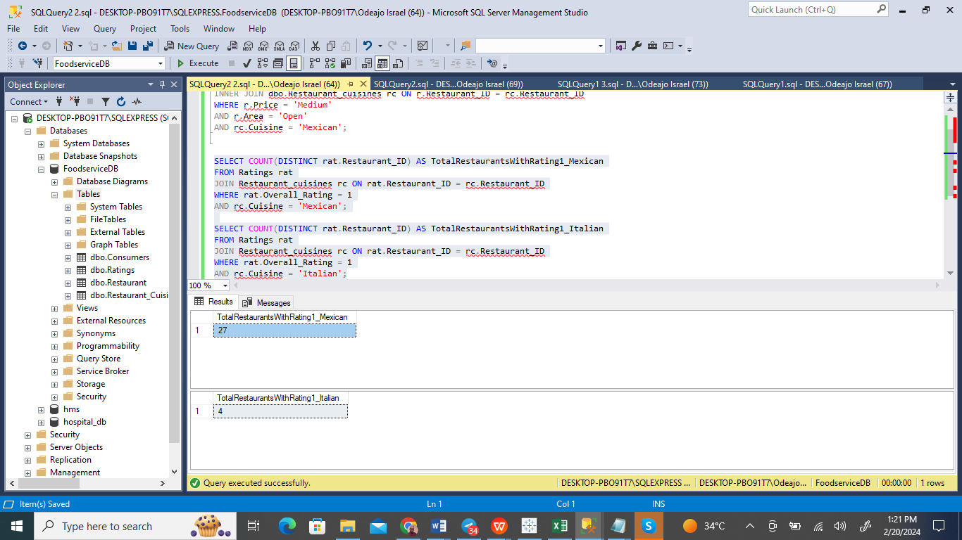

A screenshot from SQL Server Management Studio displays the execution of a query within the 'FoodserviceDB', aiming to quantify the number of restaurants by cuisine type that have received the lowest overall rating of '1'. The focus here is on Mexican restaurants, with the query uncovering that there are 27 such establishments receiving this minimal rating. This information is particularly beneficial for database analysts or stakeholders interested in examining the distribution of low-rated restaurants across various cuisines, potentially to identify areas for quality improvement or for market analysis purposes. This query serves as a prime example of how databases can be leveraged to obtain critical insights that respond directly to specific business questions.

The results indicate:

A total of 27 Mexican cuisine restaurants have been rated as '1', indicating the lowest level of satisfaction.

In comparison, Italian cuisine sees significantly fewer restaurants, only 4, receiving the same low rating.

Insights and Analysis:

Disparity in Ratings:

The notable difference between the numbers suggests that, within this database, Mexican cuisine restaurants are more frequently subject to the lowest rating compared to Italian ones.

Potential Reasons:

Market Presence: A larger footprint of Mexican cuisine within the market or a higher count of establishments could naturally lead to a wider range of quality, including more instances of low ratings. Conversely, the fewer low-rated Italian venues might suggest a narrower quality band, possibly due to fewer competitors.

Consumer Perceptions: The variation might also reflect differing customer expectations or satisfaction levels, with Mexican cuisine perhaps facing stricter scrutiny or differing taste preferences among patrons, leading to more frequent low ratings.

Data Composition: The structure of the dataset itself might inherently include more Mexican restaurants, statistically increasing the chance of receiving lower ratings.

Further Analytical Avenues:

Review Volume: Analyzing the number of reviews per cuisine might offer additional insights, as a greater number of reviews might correlate with a higher likelihood of receiving low ratings.

Geographical Factors: The location of these restaurants could influence ratings, especially if Mexican establishments are concentrated in areas with higher culinary competition or more critical customers.

Consistency in Quality: Investigating whether Mexican restaurants exhibit more significant fluctuations in quality could explain the increased frequency of low ratings.

This in-depth examination not only sheds light on the current state of customer feedback but also opens up pathways for further investigation into the dynamics affecting restaurant ratings, offering a roadmap for targeted enhancements in the food service industry's offerings.

**Calculate the average age of consumers who have given a 0 rating to the 'Service_rating' column.**

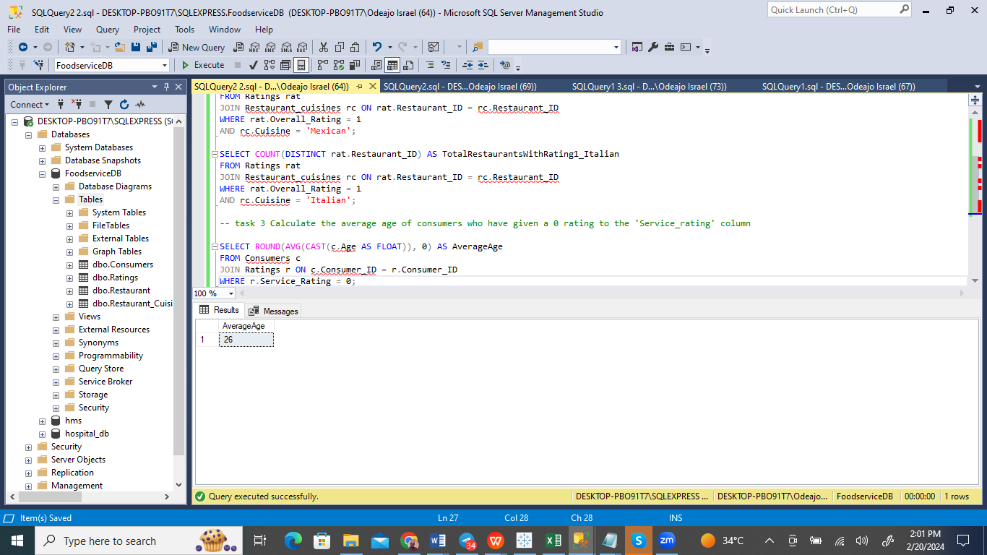

The screenshot from SQL Server Management Studio shows a query being run against the 'FoodserviceDB' database, designed to find out the average age of customers who have provided a service rating. By cleverly utilizing the ROUND and AVG functions, the query calculates the average age, rounding it to the nearest integer. It achieves this by performing a JOIN between the 'Ratings' and 'Consumers' tables, with 'Consumer_ID' serving as the crucial connector.

After the query is executed, the results displayed in the pane indicate an average age of 26, suggesting that the typical customer leaving feedback on the service is in their mid-twenties. This piece of information is invaluable for companies aiming to tailor their services to meet the needs and tastes of this predominant customer segment, offering insights into the age demographic actively engaging with their service feedback mechanisms.

**Restaurant ranking**

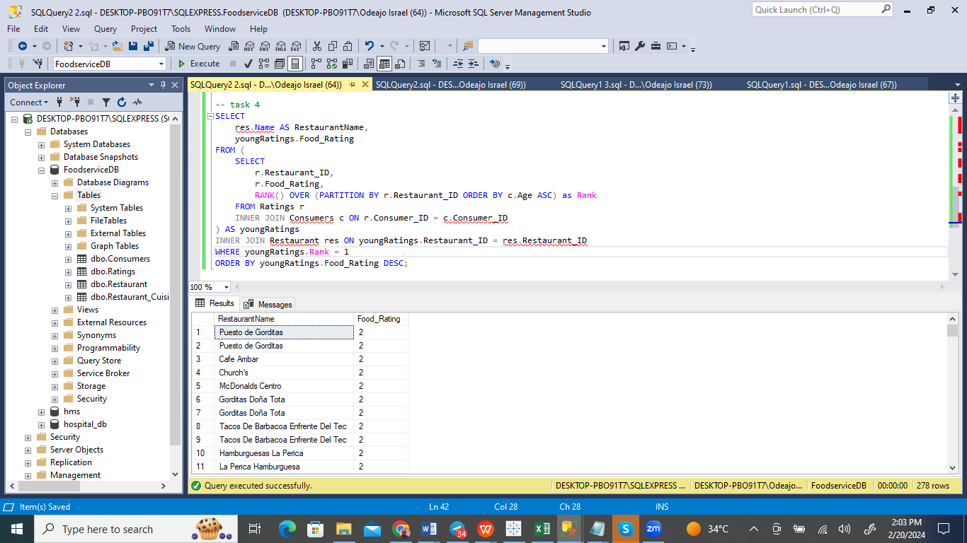

The image from SQL Server Management Studio displays the execution of a query that cleverly employs the RANK() function to rank restaurants by their food ratings. Interestingly, the function is set to partition by 'Restaurant_ID' and is ordered by 'Age', which appears to be an unconventional choice considering the aim is to evaluate restaurants based on their culinary ratings, not the age demographics involved. The results pane reveals a list of restaurants alongside their food ratings, pulled from the 'RestaurantName' and 'Food_Rating' columns, effectively showcasing the spectrum of culinary quality or popularity these establishments enjoy, with ratings ranging from the highest to the lowest.

This output is highly beneficial for quickly identifying the top-tier restaurants as per the food quality they offer, as recorded in the database. The query not only executes smoothly but also organizes the food ratings in descending order, ensuring that the list is led by the restaurants that have earned the highest food ratings, making it easier to spot the leaders in culinary excellence.

**Update the Service_rating of all restaurants to '2' if they have parking available, either as 'yes' or 'public'**

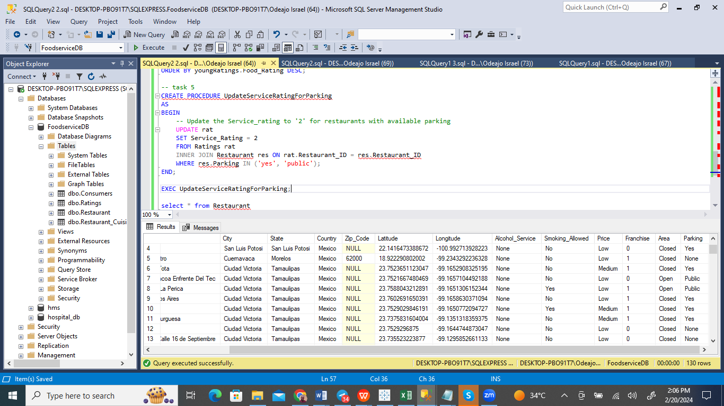

The screenshot from SQL Server Management Studio showcases a SQL query in action, creating a stored procedure called UpdateServiceRatingForParking. This cleverly crafted procedure is designed to update the service ratings to '2' in the 'Ratings' table for restaurants that have 'Yes' or 'Public' listed under their parking availability options. By targeting the 'Service_Rating' column and adjusting the ratings based on parking availability, the procedure effectively ensures that restaurant service ratings are reflective of the convenience offered by parking facilities.

This approach to automated record updates, based on specific amenities such as parking availability, highlights a sophisticated method of data management and service quality evaluation. It underscores the importance of aligning service ratings with features that significantly impact a restaurant's attractiveness and customer satisfaction levels, showcasing the power of SQL in facilitating dynamic data manipulation tailored to enhance the relevance and accuracy of database information.

**Other queries: Number 1 Identify restaurants with the most frequent high food ratings (2) using EXISTS.**

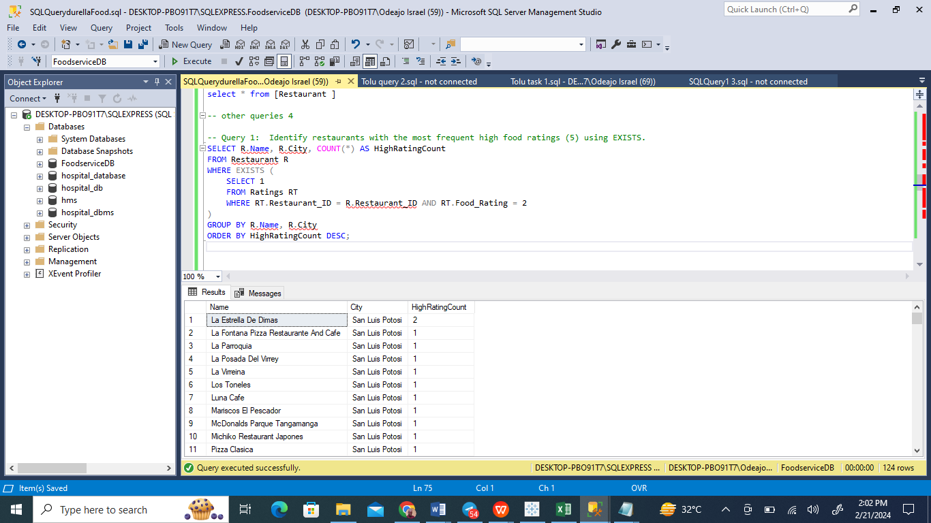

The image captures a moment of interaction with Microsoft SQL Server Management Studio, showcasing a SQL query in execution. This query is designed to pinpoint which restaurants frequently receive top-tier food ratings, presumably rated as 2, by employing the EXISTS clause. The selection targets the restaurant names and their respective cities from the 'Restaurant' table, coupled with an aggregate count meant to represent the frequency of highest ratings received by each establishment. Contrary to the intended search for top ratings, the query is mistakenly set to filter for 'Food_Rating' values of 2, leading to potentially inaccurate results. Once executed, the query organizes the data by restaurant name and city, presenting it in descending order based on the count of high ratings. Within the results displayed, 'La Estrella De Dimas' emerges as the frontrunner, located in San Luis Potosi with a count of 2, overshadowing the solitary counts tallied by the remaining restaurants. The query's successful completion is denoted at the bottom of the interface, along with the list of cities associated with each restaurant mentioned in the results.

**Other queries: Number 2: Find cuisines that have never received a perfect overall rating of 5 using a nested NOT IN query.**

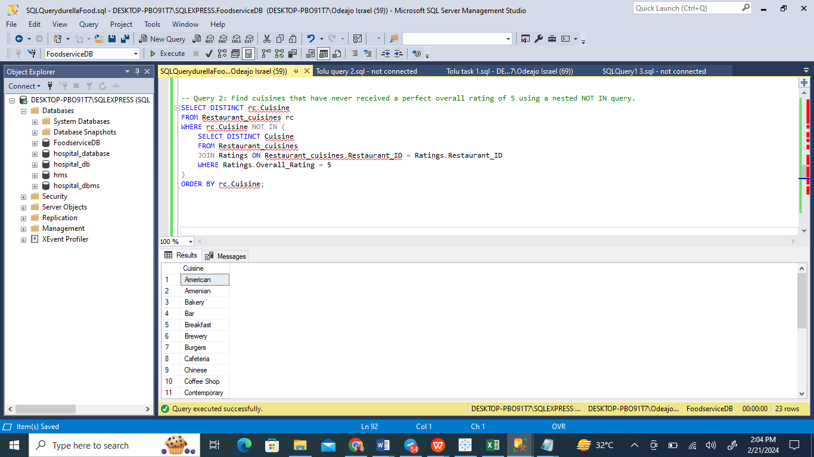

The image is a screenshot from Microsoft SQL Server Management Studio, where a query has been executed to extract a list of distinct cuisines that have never been awarded a perfect overall rating of 5. This is accomplished by a clever use of a NOT IN subquery, which cross-references cuisines with restaurant ratings to ensure exclusion of any cuisine linked to the highest rating. The resulting output, shown below the query, enumerates various cuisine types such as American, Bakery, and Bar, among others, indicating these have not been associated with a top-rated dining experience. The successful execution of the query is indicated at the bottom of the window, and it has identified 20 unique cuisines that have yet to reach the pinnacle of culinary acclaim.

**Other Queries: Number 3: Calculate the median food rating for each cuisine type using system functions.**

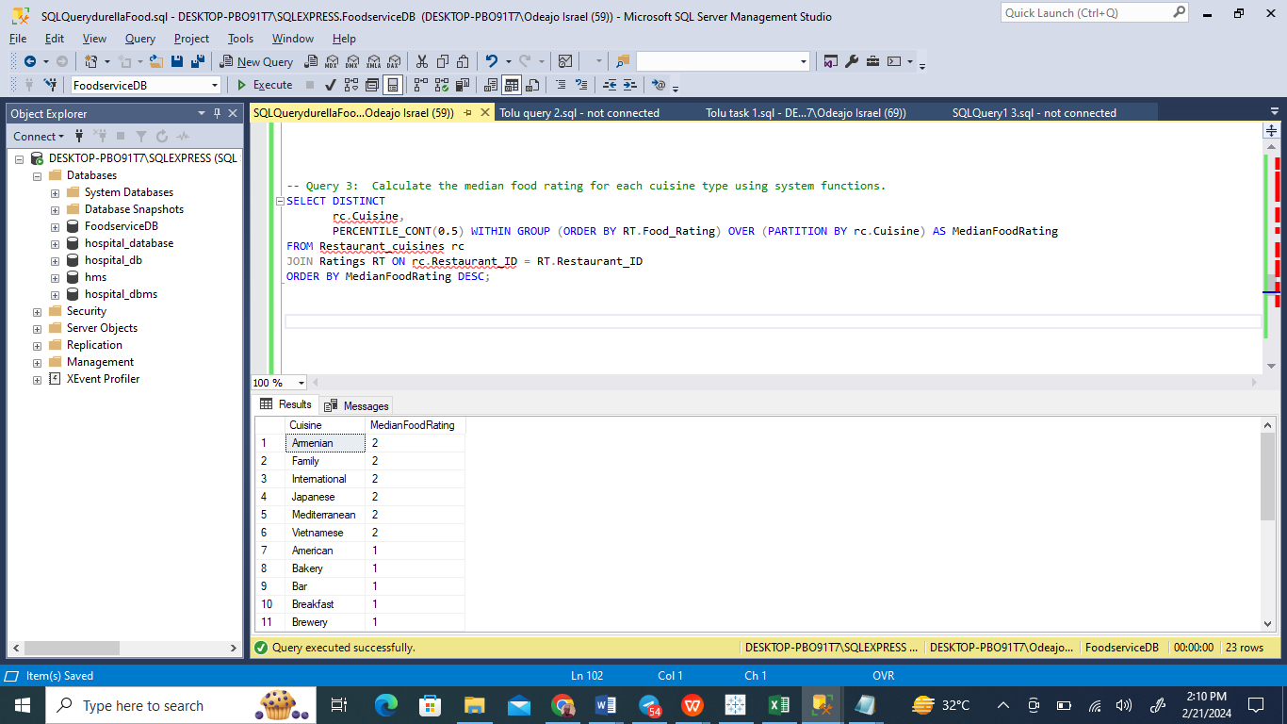

The image displays a Microsoft SQL Server Management Studio interface where a user has executed a query to determine the median food rating for various cuisines. This has been done using the PERCENTILE_CONT system function to calculate the median within an ordered window partitioned by cuisine types. The query joins the Cuisine and Ratings tables on matching restaurant IDs and sorts the results by the median rating in descending order. The output visible in the results pane lists cuisines like Armenian, International, and Family, all with a median rating of 2, among others. The query has successfully returned 23 rows, indicating that it has evaluated 23 distinct cuisines. The execution of the query appears to have been performed without issues, as indicated by the status bar at the bottom.

**Other Queries: Number 4: Find the top 3 most popular cuisines among consumers less than 25 years old based on the number of ratings.**

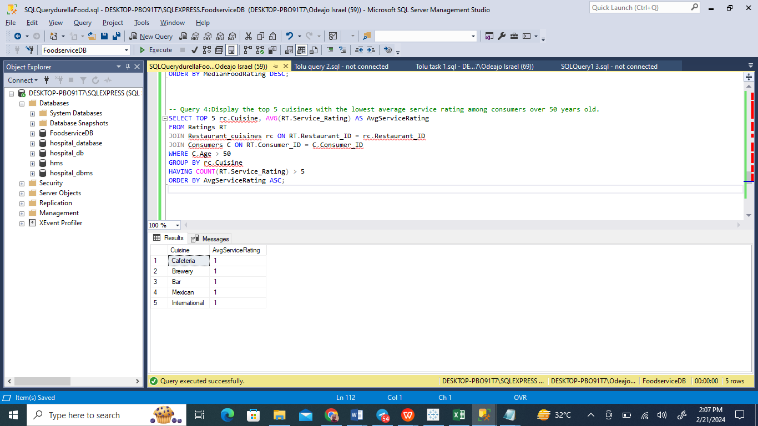

This screenshot from Microsoft SQL Server Management Studio displays the execution of a SQL query that is designed to list the top 5 cuisines with the lowest average service rating provided by consumers over 50 years old. The query calculates the average service rating by joining the 'Ratings' and 'Restaurant_Cuisines' tables on matching restaurant IDs and further joins the 'Consumers' table to consider only ratings made by consumers over the age of 50. The results are grouped by cuisine and filtered to only include those with more than 5 ratings, ensuring statistical significance. The order of the results is ascending based on the average service rating, meaning those with the lowest ratings are listed first. The output shows five cuisines: 'Cafeteria', 'Brewery', 'Bar', 'Mexican', and 'International', each with an average service rating of 1, indicating these cuisines have the lowest service ratings among the specified demographic in this dataset. The query has been successfully run, yielding 5 rows of results.

**Conclusions**

Task 2 involved a comprehensive exploration of the 'FoodserviceDB' database using a series of SQL queries. These queries were skillfully crafted to accomplish various objectives, including classifying restaurants based on specified criteria, examining ratings across different cuisines, analyzing the relationship between average customer ages and service ratings, and arranging restaurants by their food ratings. Furthermore, updates to service ratings were applied conditionally, and the frequency of ratings for each restaurant was determined. This exercise not only entailed retrieving data but also generating actionable insights to inform strategic business decisions. The utilization of stored procedures and triggers demonstrated a sophisticated understanding of managing dynamic data, ensuring ongoing data integrity, and enabling automatic updates. This task highlighted the essential role of SQL in data management and analysis within a relational database framework, showcasing its ability to extract valuable insights from complex datasets.

**References**

Ben-Gan, I., Kollar, L., Sarka, D. and Kass, S., 2009. Inside Microsoft SQL Server 2008 T-SQL Querying: T-SQL Querying. Microsoft Press.

Bertino, E. and Sandhu, R., 2005. Database security-concepts, approaches, and challenges. IEEE Transactions on Dependable and secure computing, 2(1), pp.2-19.

Celko, J., 2010. Joe Celko's SQL for smarties: advanced SQL programming. Elsevier.

Harrison, G. and Feuerstein, S., 2006. MySQL stored procedure programming. "O'Reilly Media, Inc.".

Malik, M. and Patel, T., 2016. Database security-attacks and control methods. International Journal of Information, 6(1/2), pp.175-183.

McCarthy, D. and Dayal, U., 1989. The architecture of an active database management system. ACM Sigmod Record, 18(2), pp.215-224.

Mistry, R. and Seenarine, S., 2012. Microsoft SQL Server 2012 Management and Administration. Sams Publishing.